“Raising kids is a walking in the park, and the park is Jurassic Park”

Can you tell me what made you a parent? Marriage, spouse, Allah, Bhagwan, or Jesus. That is true but this is also true that your child made you a father/a mother. Shouldn’t we respect our children. We must respect his/her individuality.

I am an imperfect father but going to tell you some perfect things that can help raising our children. I, strongly, understand that each child is unique. I have two children and both are different as individuals. A personality is a combination of a ***soul***, of a ***mind*** & of ***emotions***. Understand your child’s personality and experience the parenting. “*There is no such thing as a perfect parent. So just be a real one*” *–– said by Sue Atkins*. It is famous saying that first child eats dirt. Parent calls doctor. Second child eats dirt. Parent cleans out mouth. Third child eats dirt. Parent wonders if she really needs to feed him lunch. Hence, parenting comes through experiencing.

When do you think upbringing of a child should start? Should it start upon child’s birth? I believe it should start when the baby is in mother’s womb. Science tells us that while still in mother’s womb the baby starts hearing sounds between 18 weeks and 25 weeks. The baby can respond to such sounds. So be careful about the environment when baby is getting developed inside mother’s womb.

Those who have kids, recall the moment when you held your baby first time. You felt on top of the world. Right? What happened after few years? When your child started growing through the ages, and started going to school. Still the child is yours. but you no more feel on top of the world? Do you know why?

Reason is that we start comparing our child with other children. We forget our child’s individuality. We forget his or her personality [mind, soul, emotion]. We create an ideal personality in our mind for our child. We put our emotional demands on our child. And we push such demands beyond our child’s capacity to achieve them. I am not saying that we should not push & develop your child’s personality, but to a certain limit. For example: two different cars with different horsepower cannot achieve the same results.

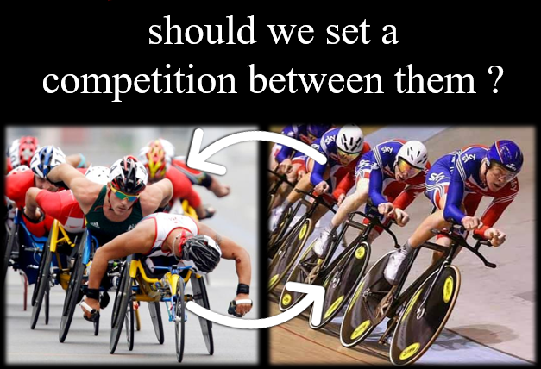

Reality is that our ego doesn’t allow us to accept that, how come my child is inferior than my cousin’s child. Commonly we evaluate our children with marks obtained in exams. We don’t evaluate them against their personality. We don’t have time to understand our own children. Remember, forcefully we cannot create an interest. Rather, we need to find out interest & capacity of our children.

When my 5 years old daughter desired my attention, I was busy on the phone or watching news on TV but she will get older and I will crave her attention. And then she would have no time for me. Because when she was of little age, she came to me with a paper aeroplane. And I didn’t give her attention, I didn’t praise her achievement. She had made a plane that can ***fly in air***. I lost hundreds of such opportunities to build good relationship through good communication. We work hard to build business relationships but have no time for our off springs’ & spouse. When they reach teenage, psychologically & biologically, they feel that they are grown enough to take decisions. And then they retaliate and we find difficulty in handling them. Because the boat has already sailed. Now, we must avail the consequences of our miscommunications. Mind it no communication also leads to miscommunications.

Now, based on my own experience, I shall give you a small list of actions to do with our children.

1. Give attention to your children. Don’t expose your child’s mistakes in front of others.
2. Never allow your children to get depressed.
3. Acknowledge them, give them thanks, show love by way of touch.
4. Children lie because we are harsh on their truth.
5. Don’t make a wrong promise or such promise that you can’t fulfil within timeframe.
6. Most importantly teach them how to say **No** in a positive way.
7. Guide them with authority. Sometimes you might have to be tough on them for things those are not good for them or could be dangerous.

Don’t try to become God for your child’s future, parents’ duty is to give them only good guidance and Almighty will do the best for your child. Three major points to keep on top of your mind.

1. Give positive suggestions to your children
2. Focus on their strengths
3. Tell them moral stories which would make them a better human-being.